**Sudha Amarnath**



**Graduate and Extended Studies**

**CMPE 202 – Software Systems Engineering**

**Spring 2019**

**Prof. Gopinath Vinodh**

# Test Cases - Starbucks Individual Assignment

**Please fetch the starbucks individual app code from below github link:**

<https://github.com/gopinathsjsu/projectindividual-SudhaAmarnath.git>

**Total 61 Testcases - passing run summary: (50 existing + 11 new)**

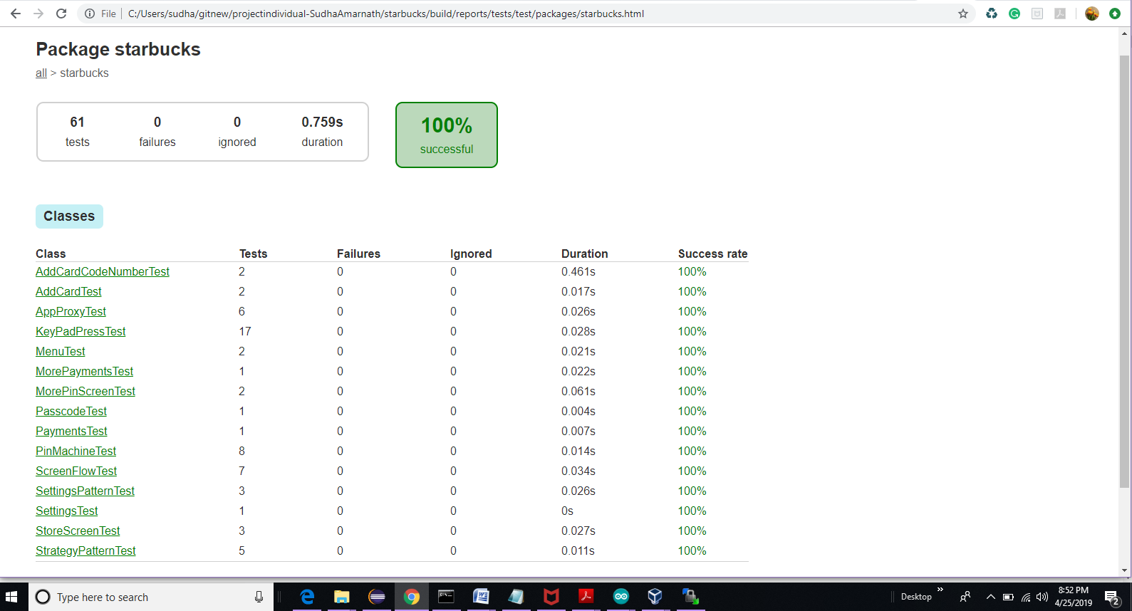

**SpotbugsMain: Application is free of spot bugs**

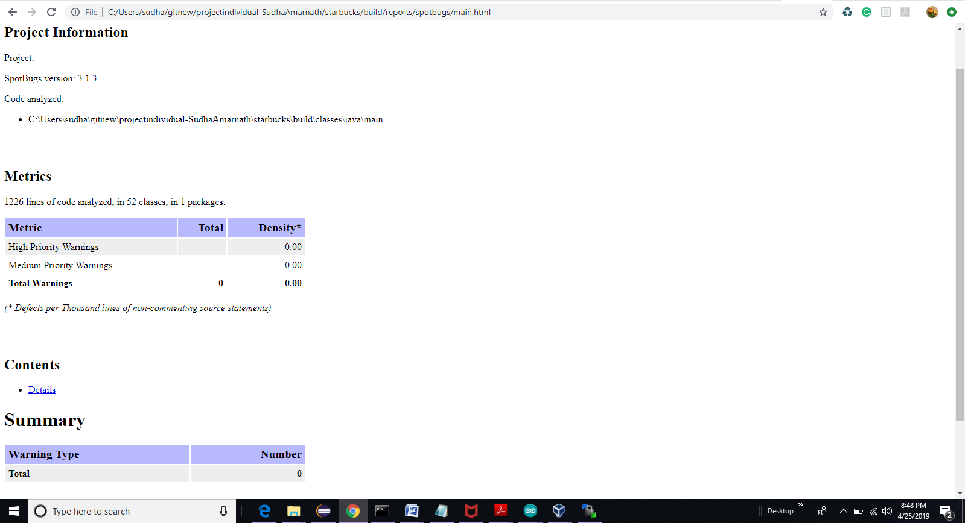

**Code smells for the application:**

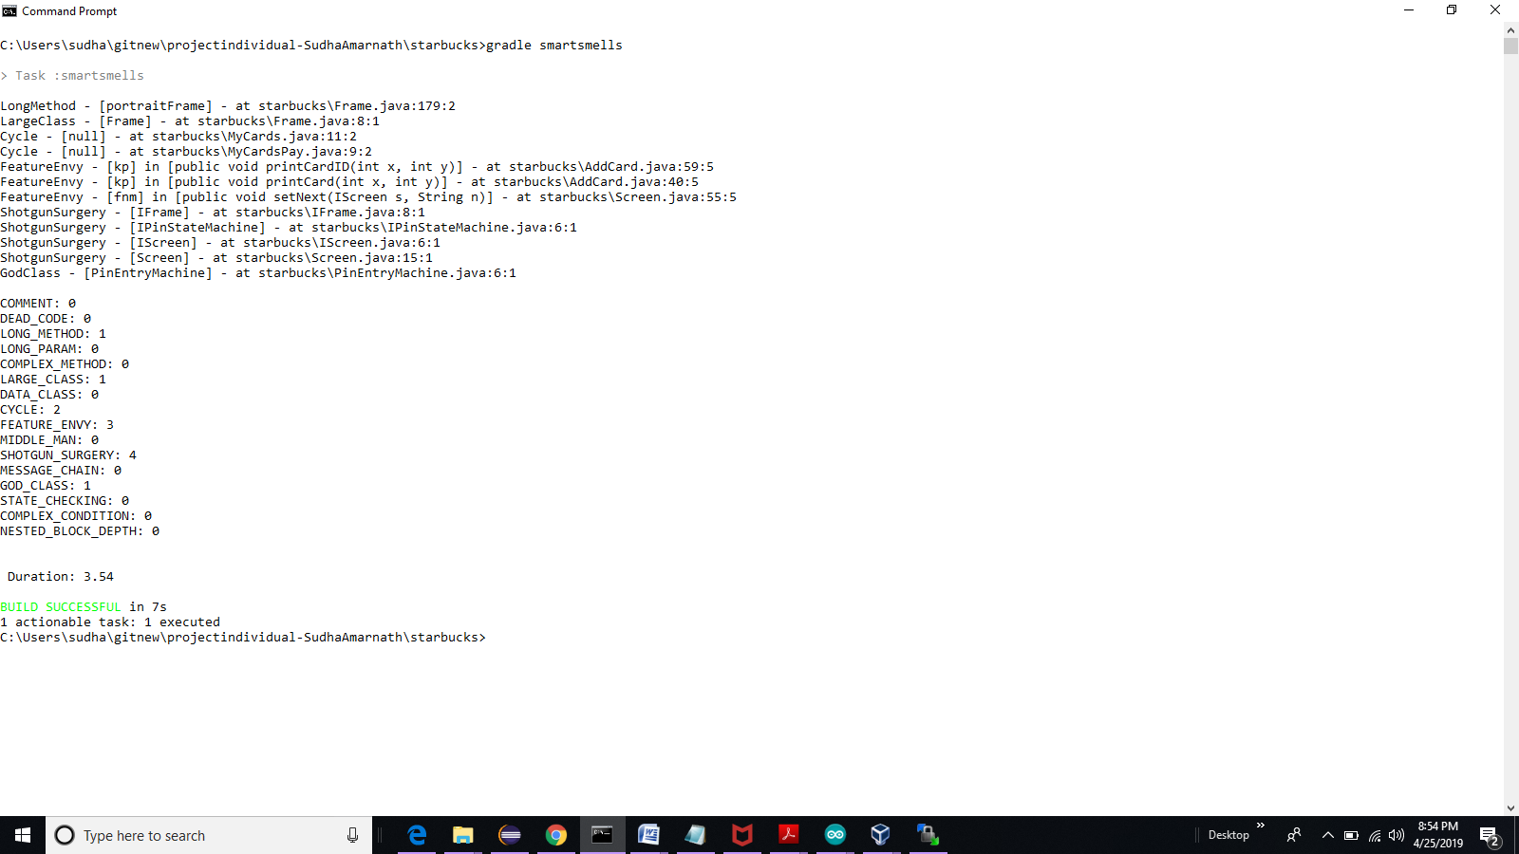

**Extra test cases added for starbucks individual project:**

## ****AddCardCodeNumberTest.java****

<https://github.com/gopinathsjsu/projectindividual-SudhaAmarnath/blob/master/starbucks/src/test/java/starbucks/AddCardCodeNumberTest.java>

**Tests result html file**



* **Test case 1 –** AddCardCodeNumberTest1()

|  |
| --- |
|  |
|  | a. Card id, press X when no digits are entered and verify |
|  | b. Add card id, digit 1 |
|  | c. Delete card id, first digit and verify |
|  | d. Add digits 12345 to card id |
|  | e. Delete last 3 digits and verify card id is 12 |
|  | f. Add next 7 card digits – 7449652 |
|  | g. Verify card id is 127449652 |
|  | h. Focus on card code |
|  | i. Card Code digits 744 |
|  | j. Verify MyCards screen |

* **Test case 2 –** AddCardCodeNumberTest2()

|  |  |
| --- | --- |
|  | a. Card id, 747449652 and focus on card code |
|  | b. Card code, press X when no digits are entered and verify |
|  | c. Add card code, digit 4 |
|  | d. Delete card code first digit and verify its empty |
|  | e. Add digits 453 to card code and verify screen |
|  | f. Delete all 3 card code digits and verify screen is empty |
|  | g. Add all card code digits 945 and focus on next screen |
|  | h. Verify MyCards screen |

## ****MorePaymentsTest.java****

<https://github.com/gopinathsjsu/projectindividual-SudhaAmarnath/blob/master/starbucks/src/test/java/starbucks/MorePaymentsTest.java>

**Tests result html file**



* **Test case 3 -** MorePaymentsTest1()

|  |  |
| --- | --- |
|  | a. Logs in user |
|  | b. Adds a new card and card code |
|  | c. Verify initial value is $20.00 |
|  | d. Make successive payments of $1.50 each in a loop. |
|  | e. Verify at each step the payment is decreased by $1.50 |
|  | f. Verify the balance at each step in the MyCards screen |
|  | g. When the balance is less than $1.50, verify no more payments can be done. |

## ****MorePinScreenTest.java****

<https://github.com/gopinathsjsu/projectindividual-SudhaAmarnath/blob/master/starbucks/src/test/java/starbucks/MorePinScreenTest.java>

**Tests result html file**



* **Test case 4 -** MorePinScreenTest1()

|  |  |
| --- | --- |
|  | a. Initial login – PinScreen |
|  | b. Verify when no keys are pressed the password space is empty |
|  | c. Verify format [_][_][_][_] |
|  | d. Press passcode 1111 |
|  | e. Verify format [*][*][*][*] |
|  | f. Verify for wrong passcode, the PinScreen is retained |
|  | g. Verify "Invalid Pin" is printed |
|  | h. Delete all the digits by pressing X |
|  | i. Enter 1234 code |
|  | j. Verify successful login and MyCards screen |
|  |
|  |
|  |
|  |
|  |
|  |

* **Test case 5 -** MorePinScreenTest2()

|  |  |
| --- | --- |
|  | a. Initial login – PinScreen |
|  | b. When pin key1 value (1) is pressed - [*][_][_][_] |
|  | c. When pin key2 value (5) is pressed - [*][*][_][_] |
|  | d. When pin key3 value (8) is pressed - [*][*][*][_] |
|  | e. When pin key3 is deleted value (X) is pressed - [*][*][_][_] |
|  | f. When pin key2 is deleted value (X) is pressed - [*][_][_][_] |
|  | g. When pin key2 value (2) is pressed - [*][*][_][_] |
|  | h. When pin key3 value (3) is pressed - [*][*][*][_] |
|  | i. When pin key4 value (4) is pressed |
|  | j. Successful login with key 1234 |
|  | k. Verify the MyCards screen |

## ****SettingsPatternTest.java****

<https://github.com/gopinathsjsu/projectindividual-SudhaAmarnath/blob/master/starbucks/src/test/java/starbucks/SettingsPatternTest.java>

**Tests result html file**



* **Test case 6 -** SettingsPatternLandscapeTest()

|  |  |
| --- | --- |
|  | a. Logs in using correct pin keys |
|  | b. Choose Settings page |
|  | c. Convert to portrait mode |
|  | d. Verifies the content |
|  | e. Convert to landscape mode |
|  | f. Verify the screen contents are intact |
|  | g. Go back to previous screen |
|  | h. Select screen My cards |
|  | i. Verify the selection works |

* **Test case 7 -** SettingsPatternPortraitTest()

|  |  |
| --- | --- |
|  | a. Logs in using correct pin keys |
|  | b. Choose Settings page |
|  | c. Convert to landscape mode |
|  | d. Verifies the content |
|  | e. Convert to portrait mode |
|  | f. Verify the screen contents are intact |
|  | g. Go back to previous screen |
|  | h. Select screen Payments |
|  | i. Verify the selection works |

* **Test case 8 -** SettingsScreenToAllOtherScreenTest()

|  |  |
| --- | --- |
|  | a. Logs in using correct pin keys |
|  | b. Choose Settings page |
|  | c. Choose other screen and back to settings |
|  | d. Verify the navigation works for all other screens |

## ****StoreScreenTest.java****

<https://github.com/gopinathsjsu/projectindividual-SudhaAmarnath/blob/master/starbucks/src/test/java/starbucks/StoreScreenTest.java>

**Tests result html file**



* **Test case 9 -** StoreScreenTest1()

|  |  |
| --- | --- |
|  | a. Logs in using correct pin keys |
|  | b. Choose Store page, key press D |
|  | c. Convert to portrait mode |
|  | d. Verifies the content, X marks the store. |
|  | e. Convert to landscape mode |
|  | f. Verify the screen contents are intact |
|  | g. Go back to previous screen |
|  | h. Select screen My cards, key press A |
|  | i. Verify the selection works |

* **Test case 10 -** StoreScreenTest2()

|  |  |  |
| --- | --- | --- |
|  | | a. Logs in using correct pin keys |
|  | | b. Choose Store page, key press D |
|  | | c. Convert to landscape mode |
|  | | d. Verifies the content, X marks each store location. |
|  | | e. Convert to portrait mode |
|  | | f. Verify the screen contents are intact |
|  | | g. Go back to previous screen |
|  | | h. Select screen Rewards, key press C |
|  | | i. Verify the selection works |
|  |
|  |
|  |
|  |
|  |
|  |
|  |
|  |
|  |
|  |

* **Test case 11 -** StoreScreenToAllOtherScreenTest()

|  |
| --- |
|  |
|  | a. Logs in using correct pin keys |
|  | b. Choose Store screen |
|  | c. Choose other screen and back to Store screen |
|  | d. Verify the navigation works for all other screens |